**PROJECT REPORT ON**

SMARTPHONE BASED ACCESS CONTROL SYSTEM

**SUBMITTED BY:**

ASHWIN S MURTHY

ASHIK G GINIYA

ANUSHA P S

JOY STEFFI JONES

LYNETTE W PINTO

K RISHABH

**ABSTRACT OF THE PROJECT:**

This project is aimed at developing a system capable of controlling an LED from any part of the world using a smart phone by making use of the concept of Internet of Things (IoT).

The Internet of Things is a system of interrelated computing devices, mechanical and digital machines, objects, animals or people that are provided with unique identifiers and the ability to transfer data over a network without requiring human-to-human or human-to-computer interaction.

In this project, by the means of an application installed on the smart phone, users can implement an up counter from 0 to 7 via the Do button application

**REQUIREMENT SPECIFICATION:**

1. **HARDWARE :**
2. Particle photon
3. Android/Apple Smartphone/ Tablet PC
4. Personal Computer/Laptop
5. LED
6. Resistor
7. Bread board
8. USB to micro USB cable
9. **SOFTWARE :**
10. Particle app
11. Particle IDE
12. An account under IFTTT and particle
13. Do button app by IFTTT

**SYSTEM DESCRIPTION:**

**PARTICLE PHOTON:**

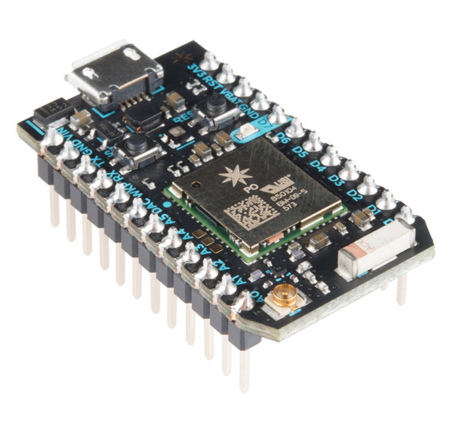

The system consists of the Particle Photon board as its core. The device to be controlled(LED) is physically connected onto the board through either the digital or analog pins on the board. The Photon is a tiny Wi-Fi development kit for creating connected projects and products for the Internet of Things.

 The Photon is the signature Wi-Fi development kit, perfect for projects and prototypes. Photons in Trays are a great choice for small and quick production runs or pilots.

Based on Broadcom's WICED architecture, the Particle Photon Series combines a powerful STM32 ARM Cortex M3 microcontroller and a Broadcom Wi-Fi chip. This keeps the footprint small but the function broad.

**IFTTT:**

The system is controlled using the **IFTTT** “Do-button” app, thereby allowing the user to control the appliance wireless over the internet.

**IFTTT** is a free web-based service that allows users to create chains of simple conditional statements, called "recipes", which are triggered based on changes to other web services such as Gmail, Facebook, etc. IFTTT is an abbreviation of "If This Then That".

**RECIPES** are simple connections between products and apps. There are two types of Recipes: DO Recipes and IF Recipes.

**DO Recipes** run with just a tap and enable you to create your own personalized Button, Camera, and Notepad.

### IF Recipes run automatically in the background. Create powerful connections with one simple statement — if this then that.

IFTTT employs the following concepts.

* **Channels** are the "basic building blocks of IFTTT", they mainly describe a series of data from a certain web service such as YouTube or eBay. It can also describe some actions controlled with certain APIs like SMS. Sometimes, it can represent information in terms of weather or stocks. There are particular triggers and actions in each channel.
* **Triggers** are the "this" part of a recipe. They are the items that "trigger" the action. For example, from an RSS feed, you can receive a notification based on a keyword or phrase.
* **Actions** are the "that" part of a recipe. They are the output that results from the input of the trigger.
* **Ingredients** are basic data made available from a trigger. For example, the data that are available from the email trigger include subject, body, attachment, received date, and the sender’s address.

To achieve this, first a function is declared in the particle cloud space. This function is then designed and developed to control the appliance connected with the board. Once that is done, the function is merely called using the Do-button app with the appropriate parameters.

**BLOCK DIAGRAM:**

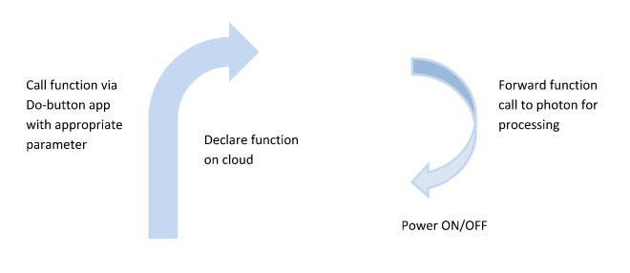

**CIRCUIT DIAGRAM:**

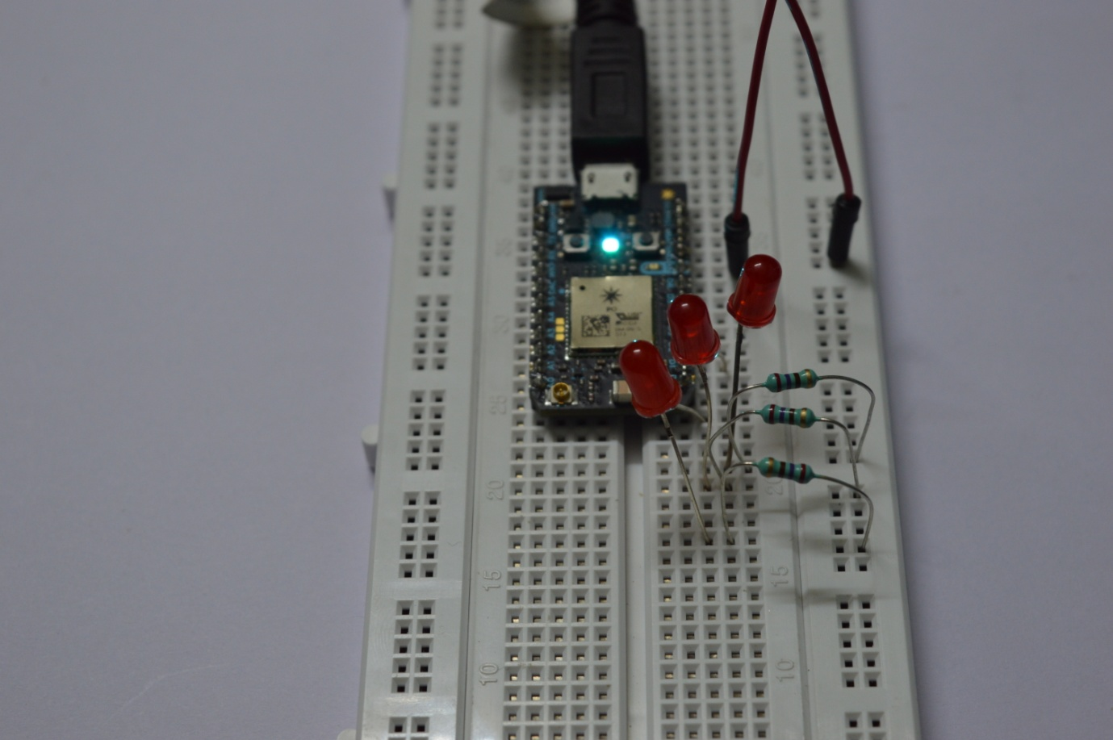

**APPLICATION CODE:**

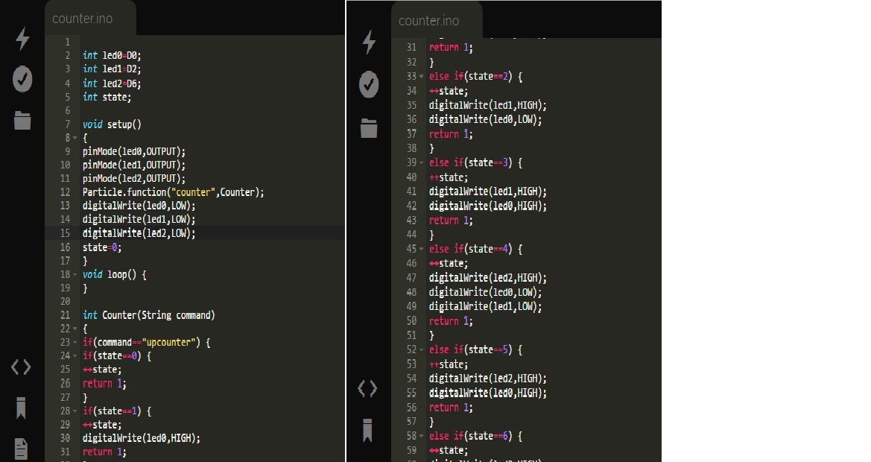

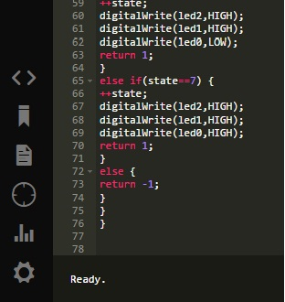

**CONCLUSIONS AND CHALLENGES:**

With all the accumulated effort, the project successfully showed desired results corresponding to the problem statement. This project can be modified to facilitate the working of real world objects such as smart phone controlled fans or smart phone controlled doors.

Some of the main challenges faces through the course of the project were

1. Understanding the working of the “do button” app and integrating it with the function written over the cloud.
2. Coding the function that switches the led on/off as per the need